AWS STORAGE:  
Setting billing alarm in AWS:

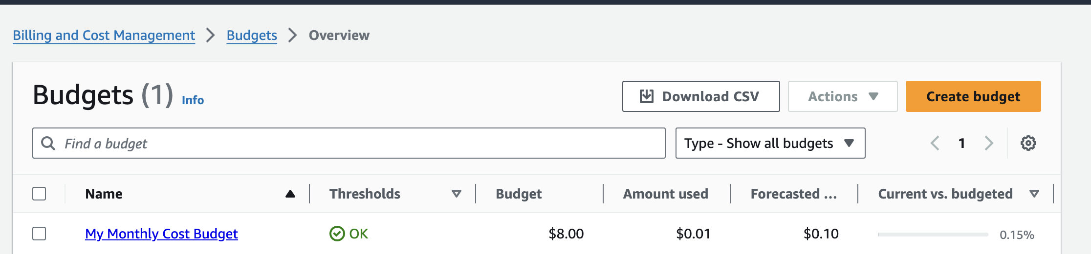

AWS S3 (SIMPLE STORAGE SERVICE):

* **It is a object based storage where data is stored as objects. Difference between object and block based storage is in block based storage we can install programs and run OS ex: Hard Disk on laptop, where is object based we can only store the data and can’t run any OS**
* 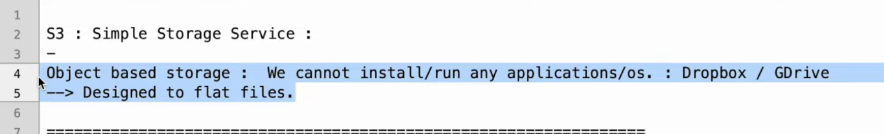
* **Buckets are nothing but folders, name should be unique as the data stored in bucket can be made public and accessed over internet**
* Bucket name should be unique across the regions in AWS
* **Max individual object size is 5TB**
* **If uploading more than 5GB we need to use multi-part upload, for example if we want to upload data of 5TB, then we need to have 1000 parts of 5GB**
* We can make object public in 2 ways, one is using ACL(Access Control List)and other is bucket policy
* If I don’t have “.” In bucket name there it creates virtual path else it
* <https://atulutayt.s3.ap-south-1.amazonaws.com/Screenshot+2024-11-10+at+11.53.04+AM.png>
* <https://s3.ap-south-1.amazonaws.com/atul.yt.demo/Screenshot+2024-11-10+at+11.53.04+AM.png>
* 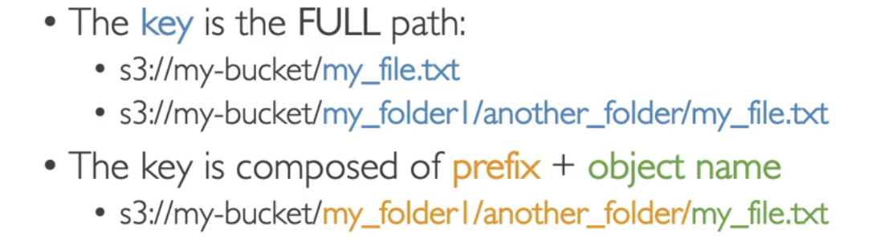
* To enable ACL: 
* 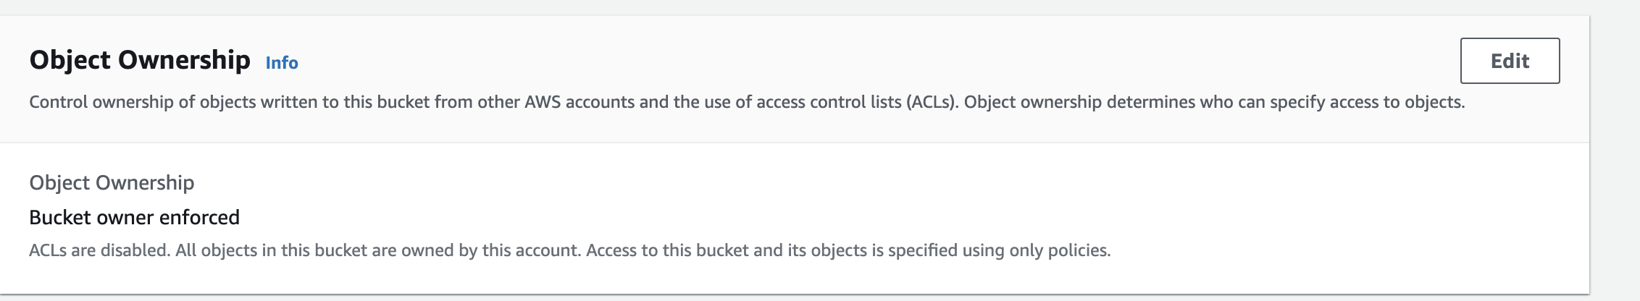
* 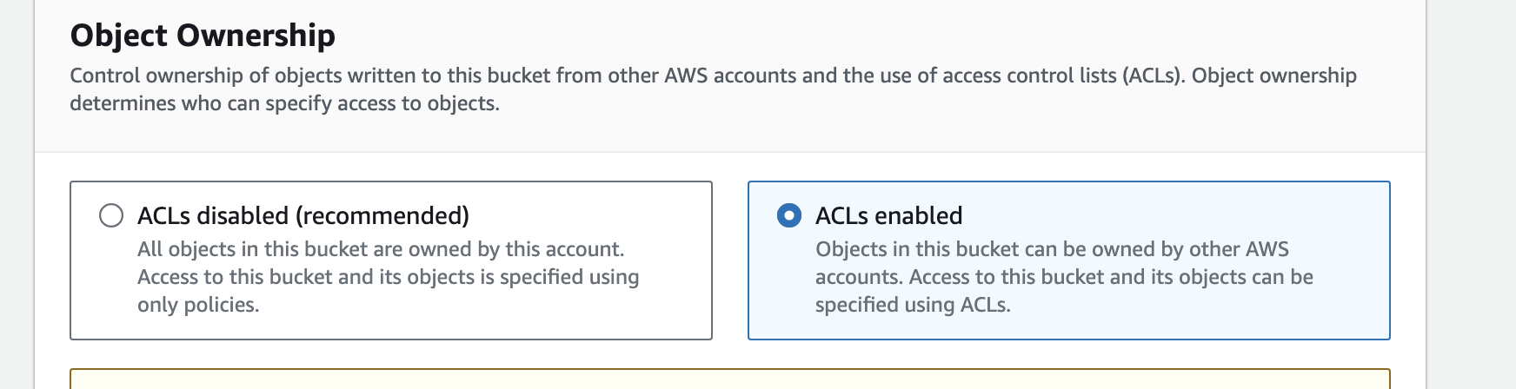
* 
* **In ACL we need to make all object public by selecting it, if I don’t want that then I can go for bucket policy**
* **Based on Access pattern (Access pattern is nothing but how frequent I access data and how fast I want to retrieve data) we can decide storage class**
* 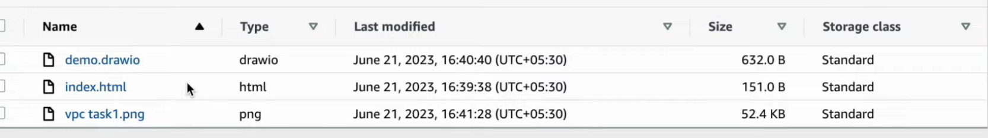
* **Availability zone is single or collection of data centres**
* **For standard it maintains 3 copies in backend**
* **For glacier class, we need to restore first and then access it**
* 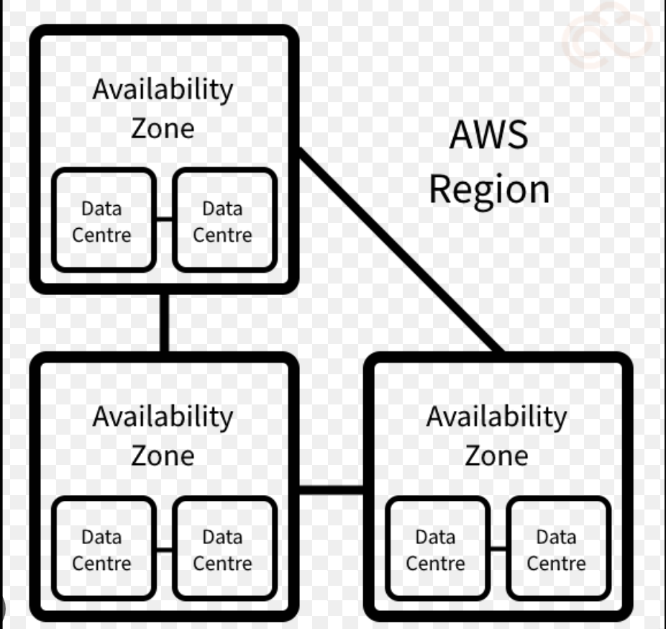
* 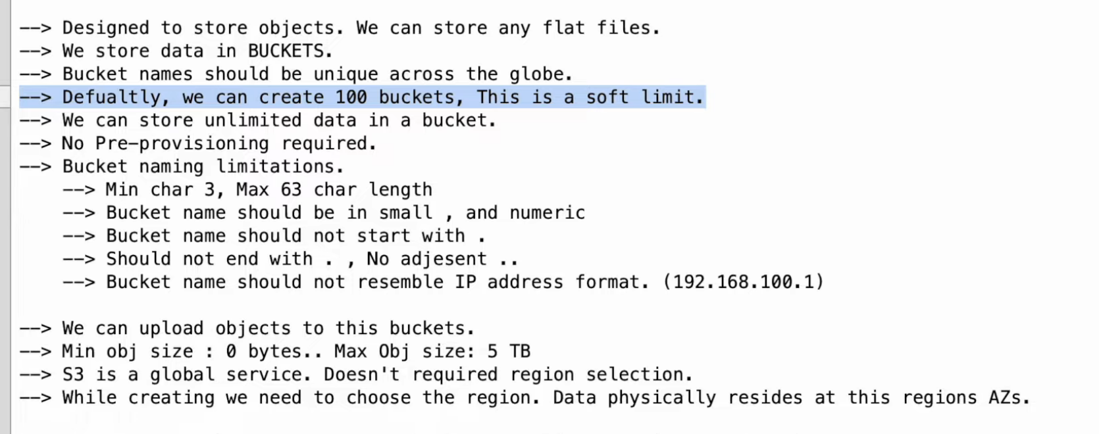
* 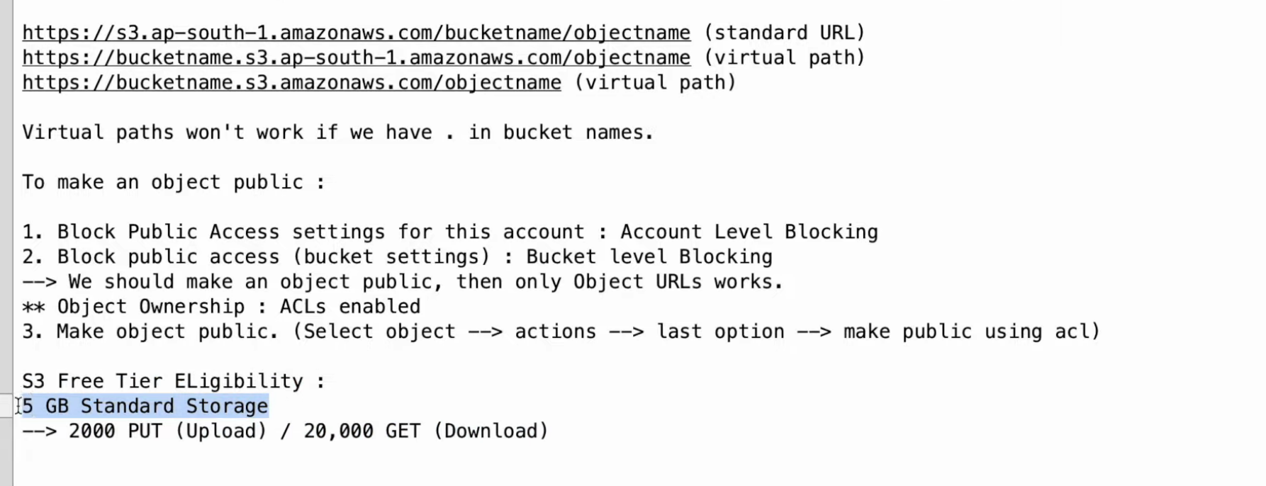
* 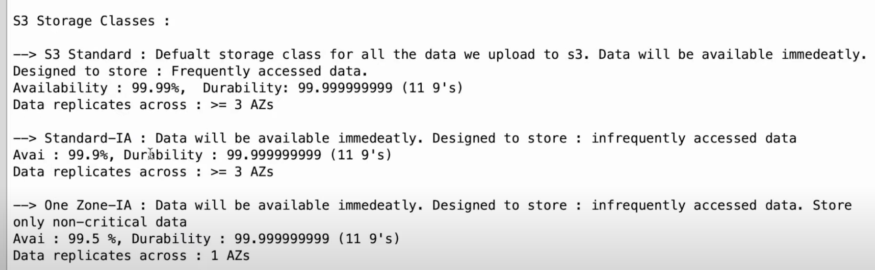
* 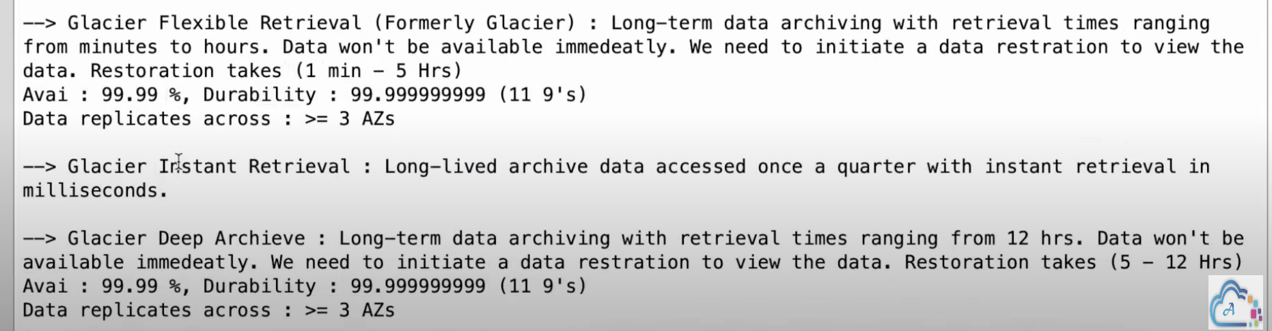
* 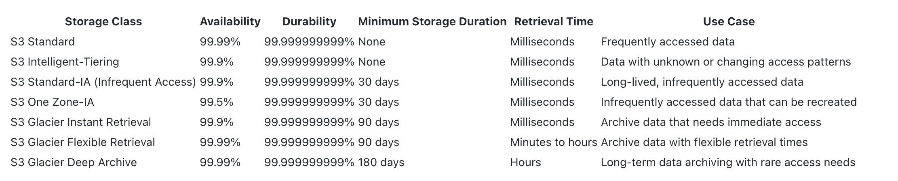
* 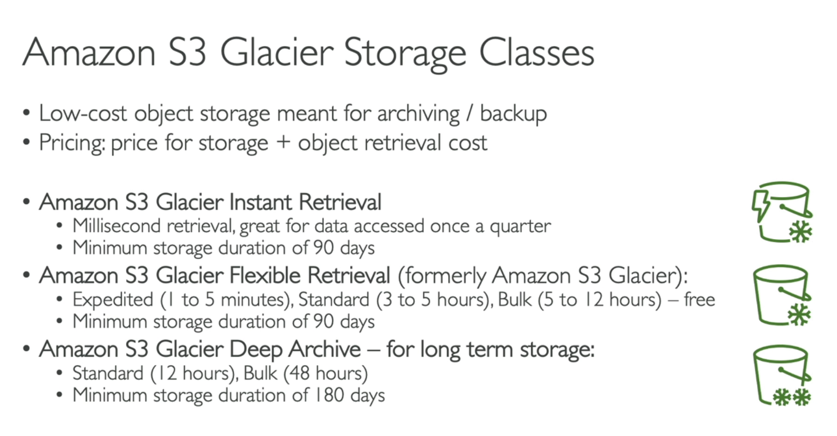
* **Minimum Duration**: **If you delete an object before it has been stored for 90 days, you will be charged a pro-rated cost for the remaining days to meet the 90-day minimum.**
* 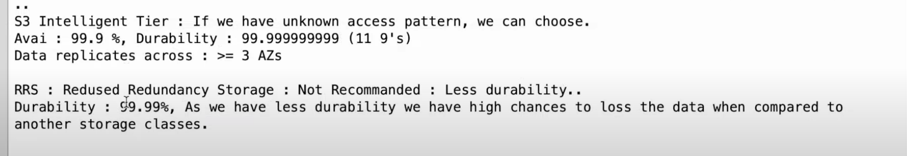
* 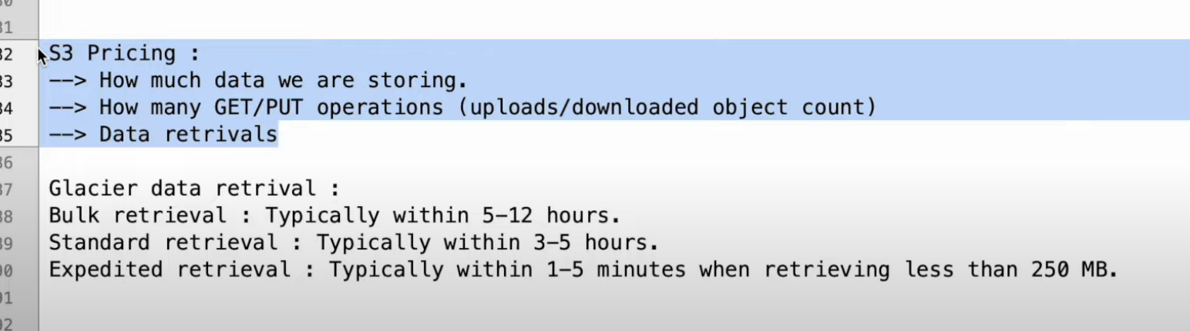

Bucket Versioning:

* Without versioning delete data can’t be rolled back
* Here versioning is done based on uploaded time
* If you reupload same file still it manages version as versioning is done based on uploaded time
* Suppose if I deleted versioned file by mistake, I can get it back by deleting delete marker
* 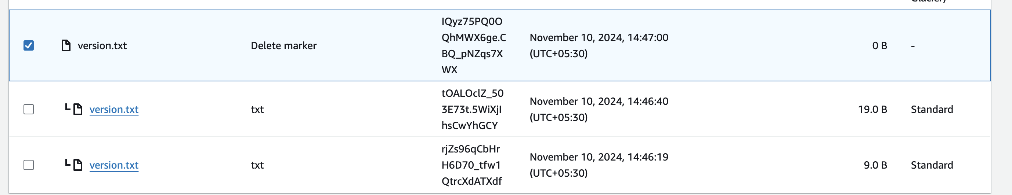

Replication:

* Replication helps to save data in different geographical location
* If replication bucket is in same region then it is called same region replication else if it is in another region it is called cross region replication, But data transfer cost will be applicable for cross region replication but not for same region replication
* 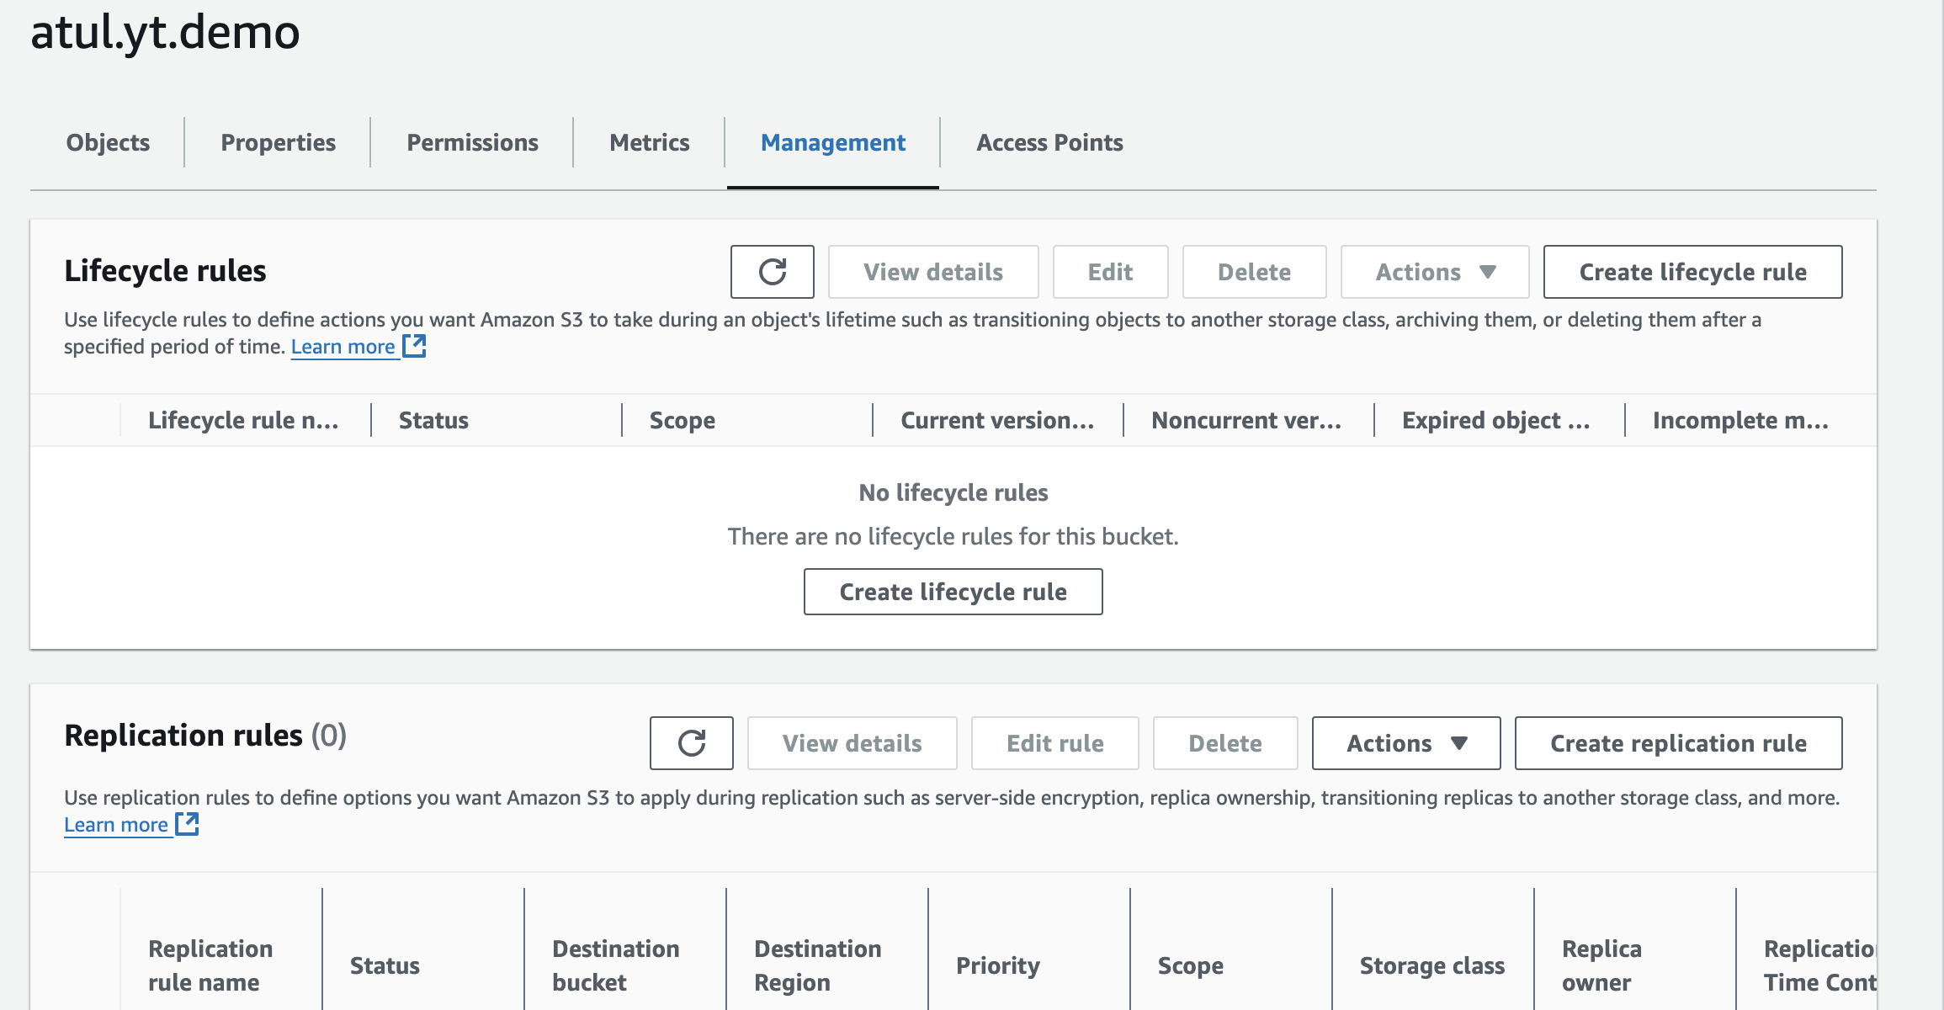
* For replication versioning should be enabled from both source and destination bucket

Life Cycle Management Roles:

* 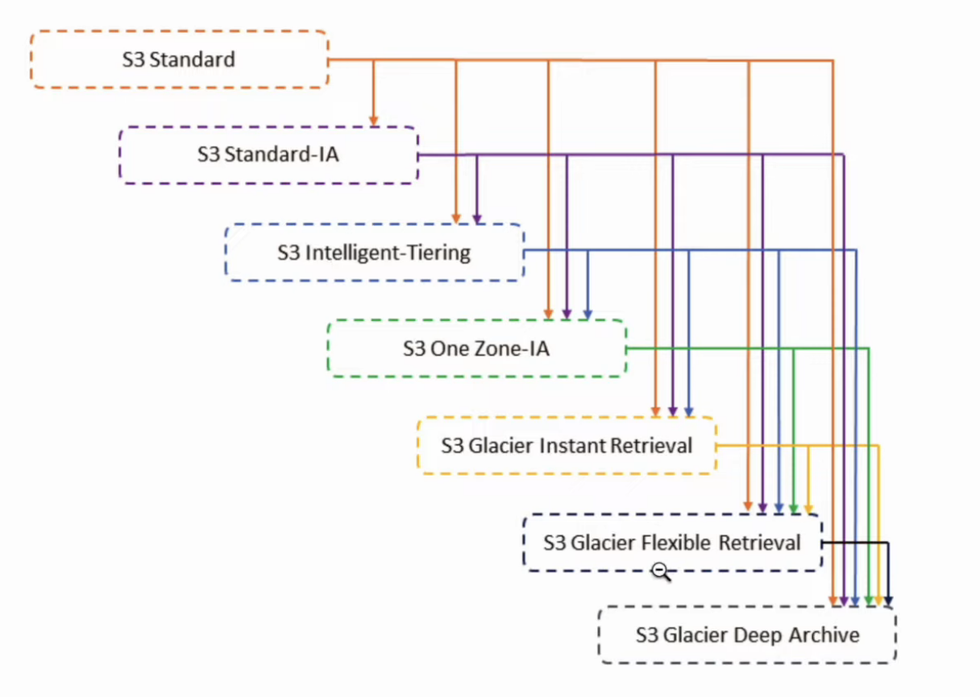
* 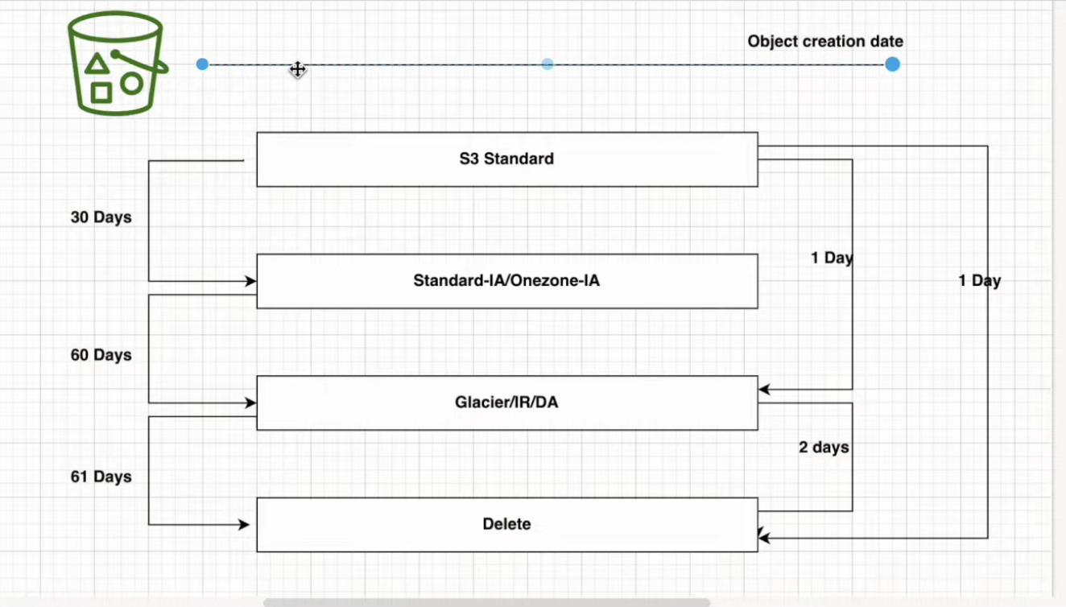

60 days is from object creation date not from standard to IA

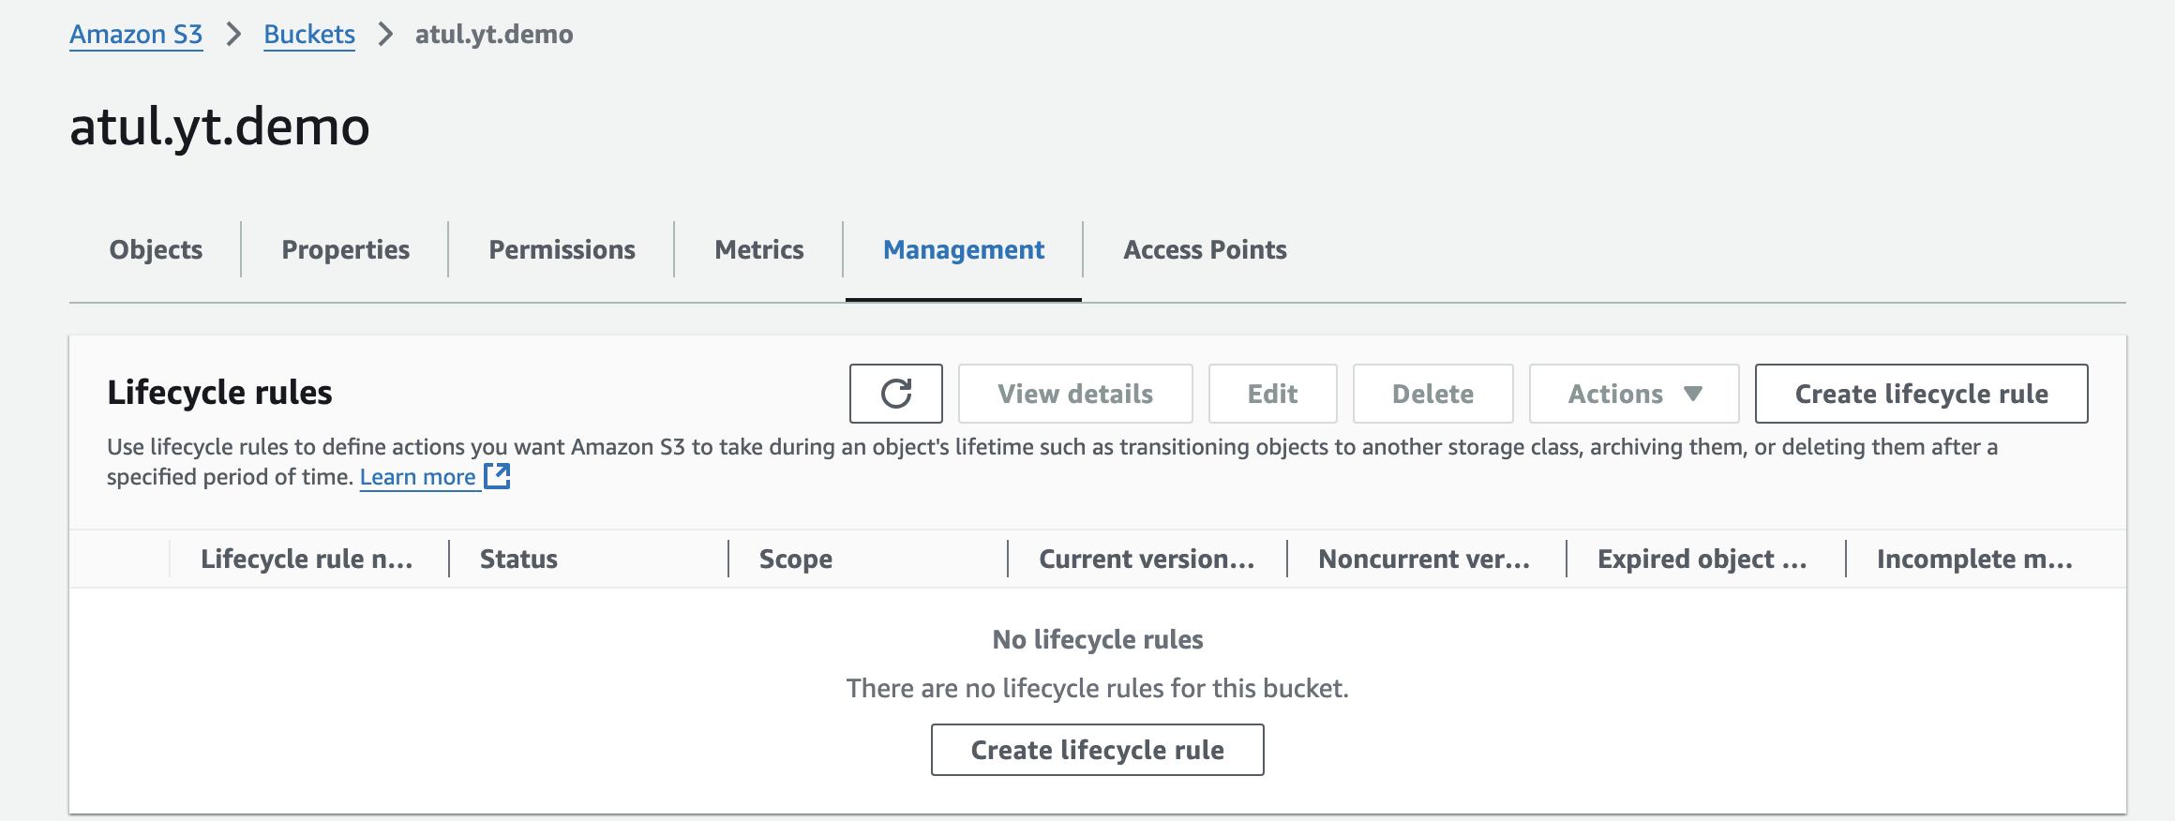

Life cycle can be set for **Current version  & non current version**

Event Notifications:

* When something happens in our s3 bucket we can get notifactions, we can use SNS service for the same
* 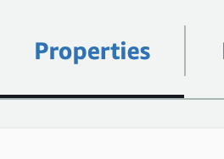
* 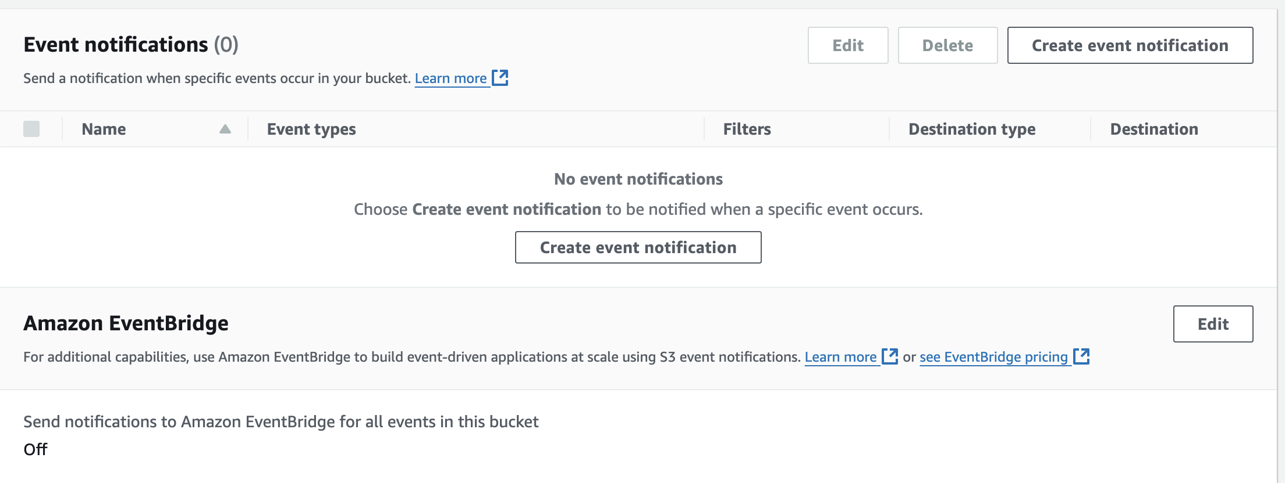
* 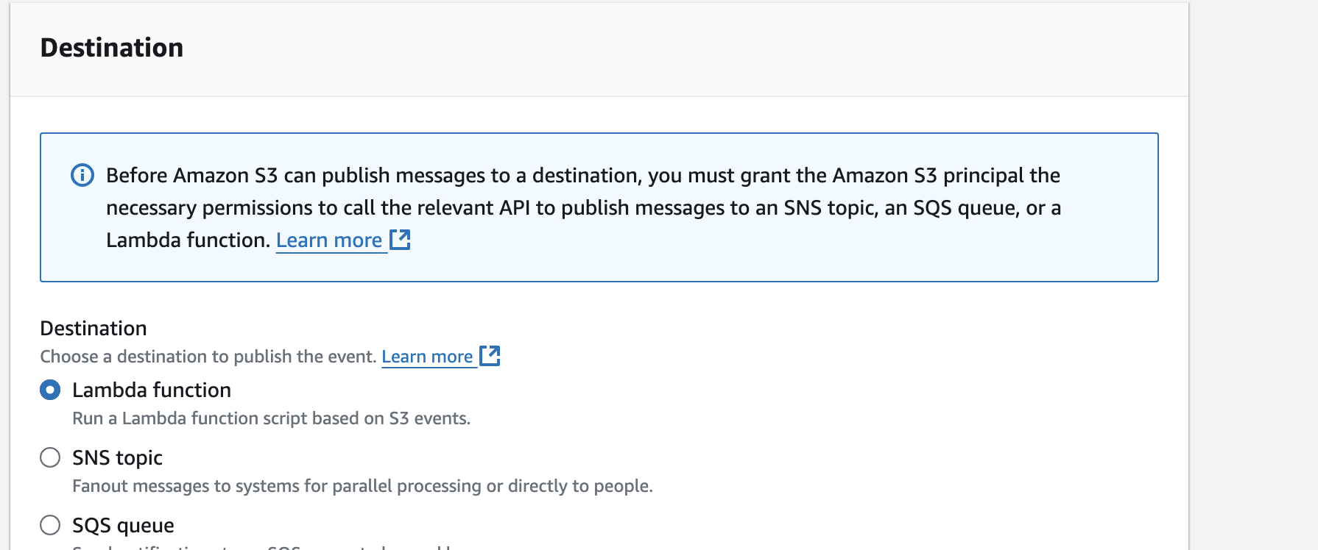
* 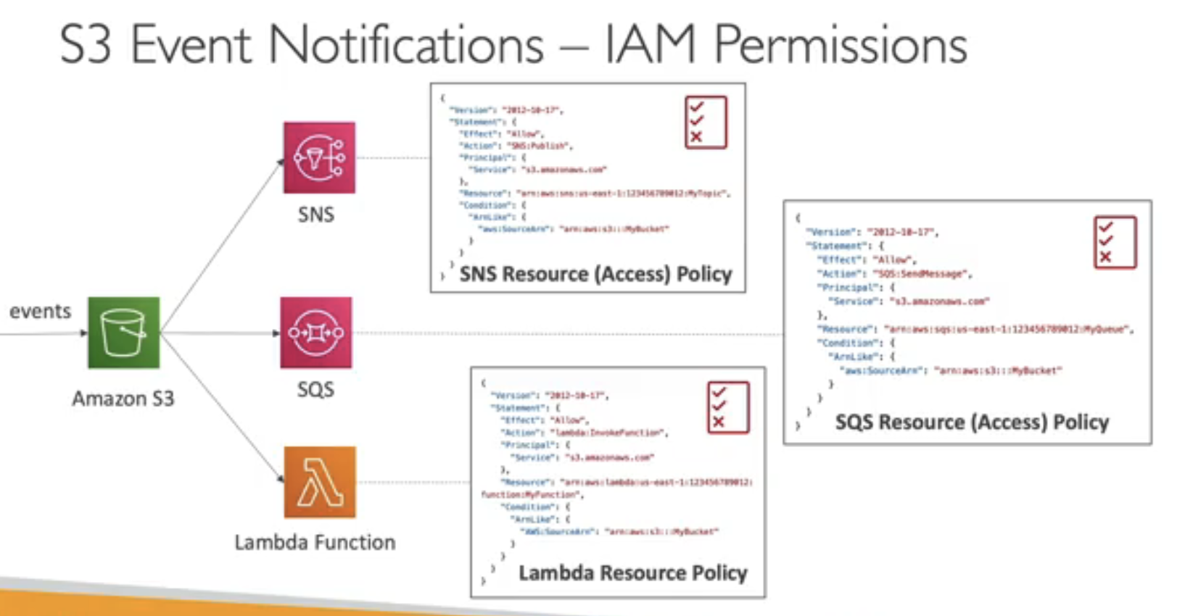
* Event Bridge is much more advanced based on some events, if I want to stop or start and ec2 instance or do some action related aws services we can use event bridge
* Amazon S3 EventBridge is an integration between **Amazon S3** and **Amazon EventBridge** that allows you to set up automated, event-driven workflows in response to changes in S3. By using EventBridge with S3, you can detect specific S3 bucket events and trigger a range of automated actions, such as initiating Lambda functions, activating workflows in other AWS services, or notifying external systems through custom applications.
* 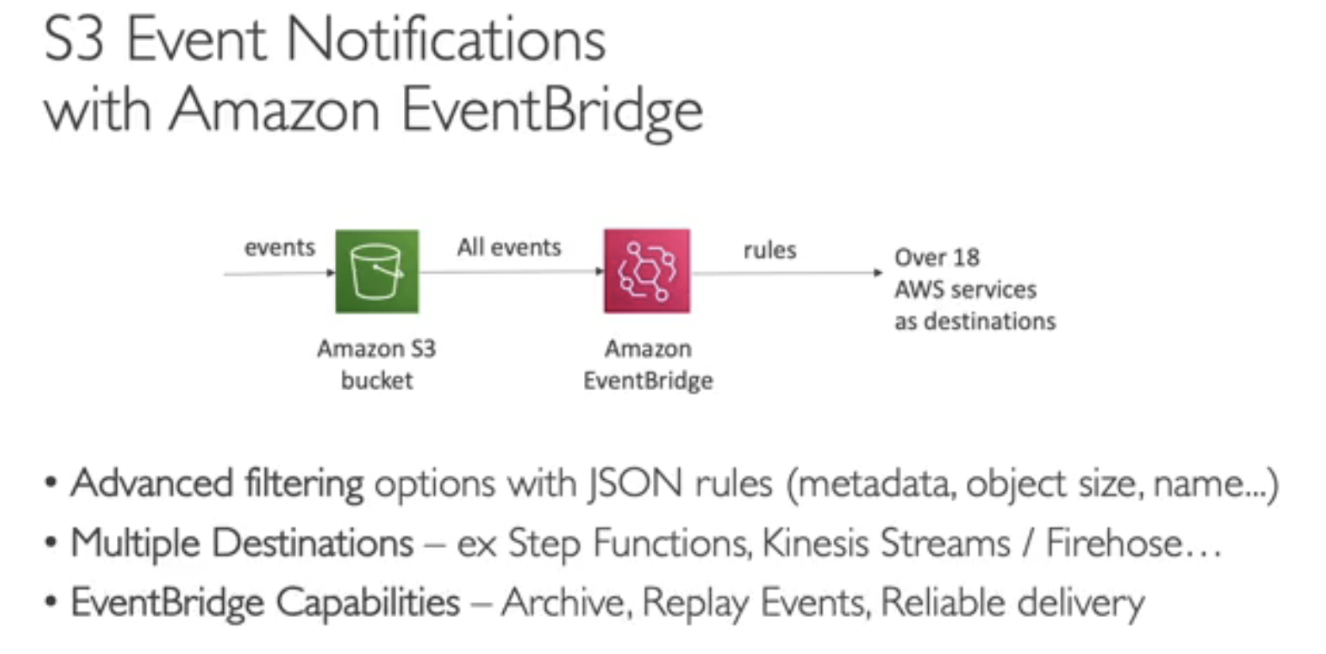

Static Website Hosting:



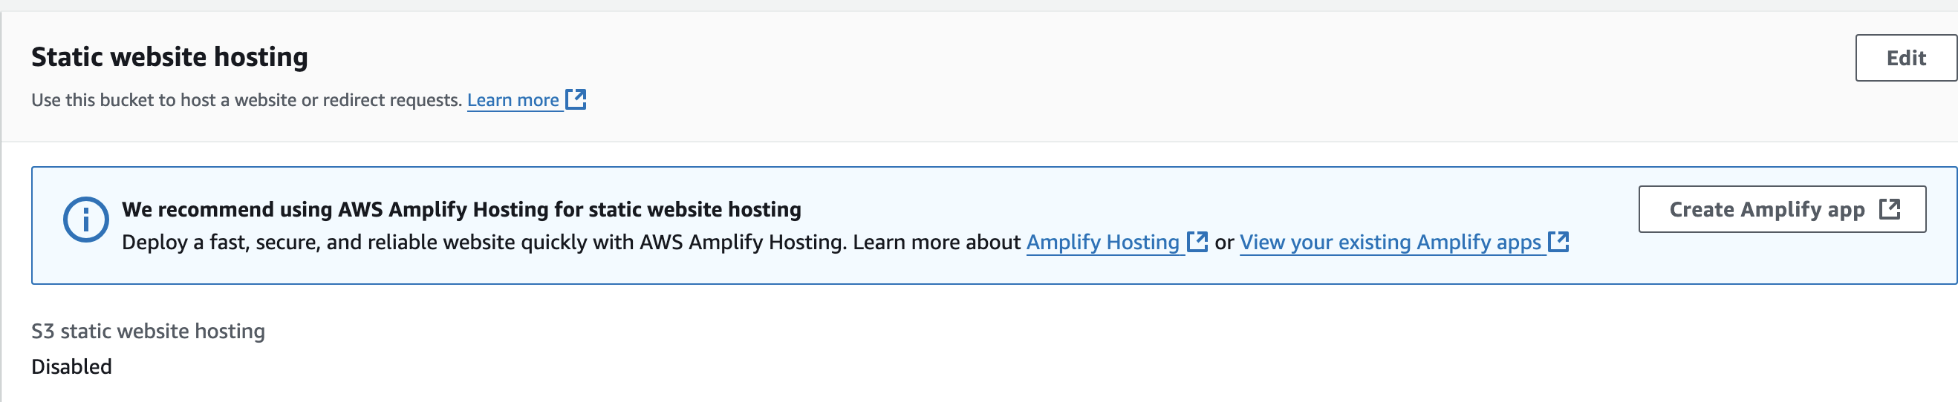

Bucket Policy:

* It allows us to manage permissions at bucket level
* Suppose I have 2 users on same account and for one user I want to restrict delete access on the bucket
* I have added a policy where even user has full s3 access he can’t delete objects in s3 bucket
* 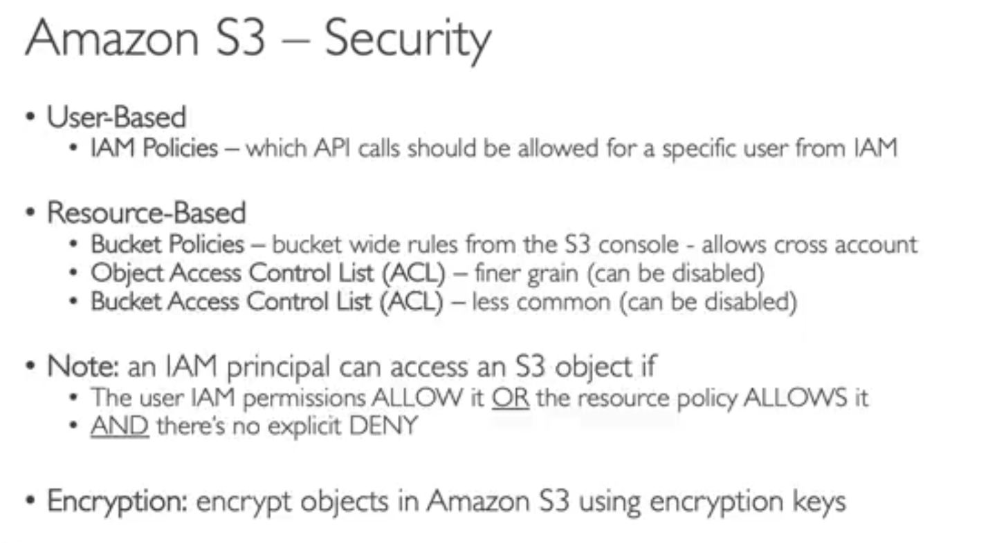

Object Lock:

* Helps in disabling mistake deletion of files are specific duration
* It won’t allow anyone to delete file
* At the time of creating bucket we need to set this feature, we can’t do once bucket is created, in that case we need to contact AWS support
* Versioning must be enabled and retention must be mentioned
* 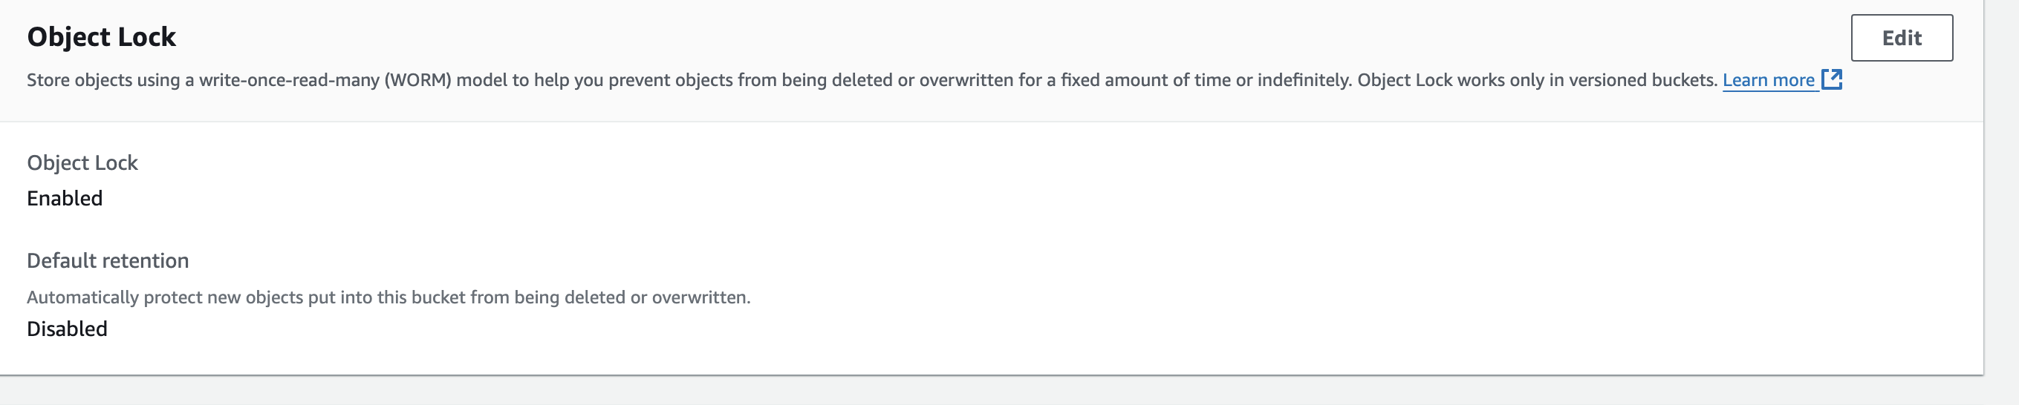
* Even if we disable object lock we can’t delete file till retention period has expired else we need to close AWS account

Extra Features:

We can enable server access logging and CloudTrail data events

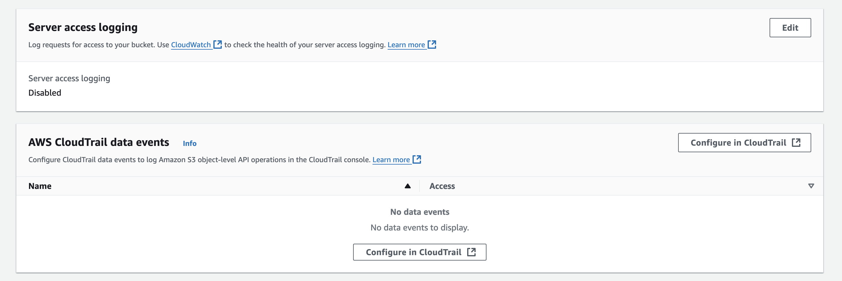

An **edge location** is a geographically distributed site that Amazon Web Services (AWS) uses to cache content closer to end users, providing faster access and lower latency. Edge locations are part of AWS's **global content delivery network (CDN)** called **Amazon CloudFront** and are located in cities around the world to deliver data, applications, and content with greater speed and efficiency.

Amazon S3 EventBridge is an integration between **Amazon S3** and **Amazon EventBridge** that allows you to set up automated, event-driven workflows in response to changes in S3. By using EventBridge with S3, you can detect specific S3 bucket events and trigger a range of automated actions, such as initiating Lambda functions, activating workflows in other AWS services, or notifying external systems through custom applications.

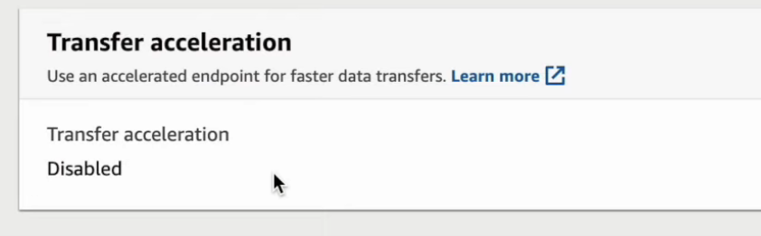

Requester Pays:

The requester has to pay the cost, here anonymous access will be disabled and requester has to pay

Intelligent access pattern can be used if we are not user about data access pattern

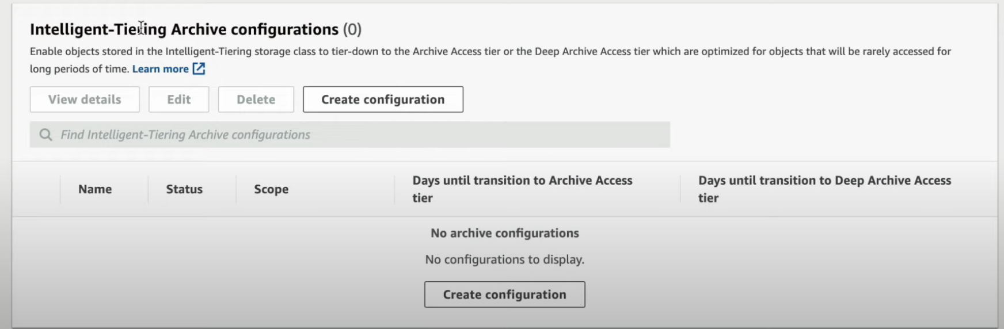

**S3 Inventory Report Summary**

**Amazon S3 Inventory Report** is a scheduled report that provides detailed metadata about objects in an S3 bucket, helping with storage management, auditing, and cost optimization.

* **Content**: Lists objects and metadata, including:
  + Object name, size, last modified date, storage class, encryption status, replication status, and tags.
* **Format Options**: Reports are generated in CSV, ORC, or Parquet format for easy integration with analytics tools.
* **Frequency**: Configurable as **daily** or **weekly** reports.
* **Storage Location**: Delivered as S3 objects to a specified bucket.
* **Benefits**:
  + **Auditing and Compliance**: Track encryption and replication status.
  + **Cost Optimization**: Identify objects for cheaper storage classes or deletion.
  + **Data Management**: Easily ingest into analytics tools for insights.
* **Use Cases**:
  + **Periodic Analysis** for buckets with large numbers of objects.
  + **Data Compliance Audits** to verify encryption, tagging, and replication.
  + **Cost Management** to optimize storage costs.

To set it up, go to **S3 Console > Management > Inventory configurations**, and configure destination, format, frequency, and metadata fields.

We have similar approach for storage class analysis

S3 Monitoring:

If we want to monitor entire s3, we have snapshot which has a service called storage lens

To view files outside aws console:



Cyberduck

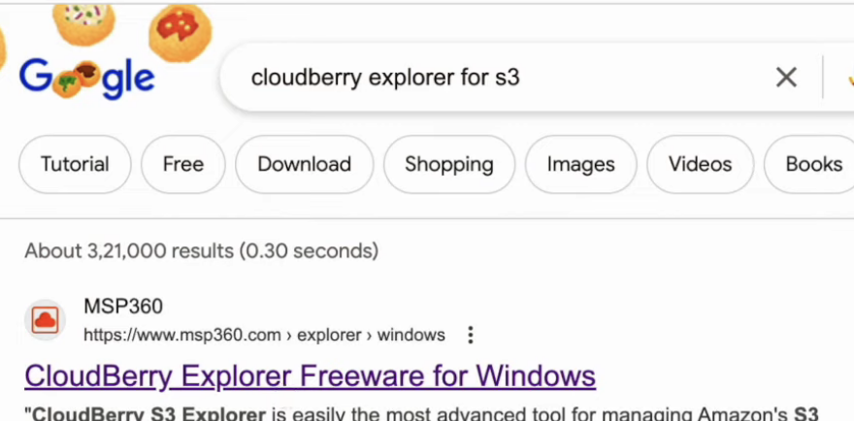

S3 Performance:

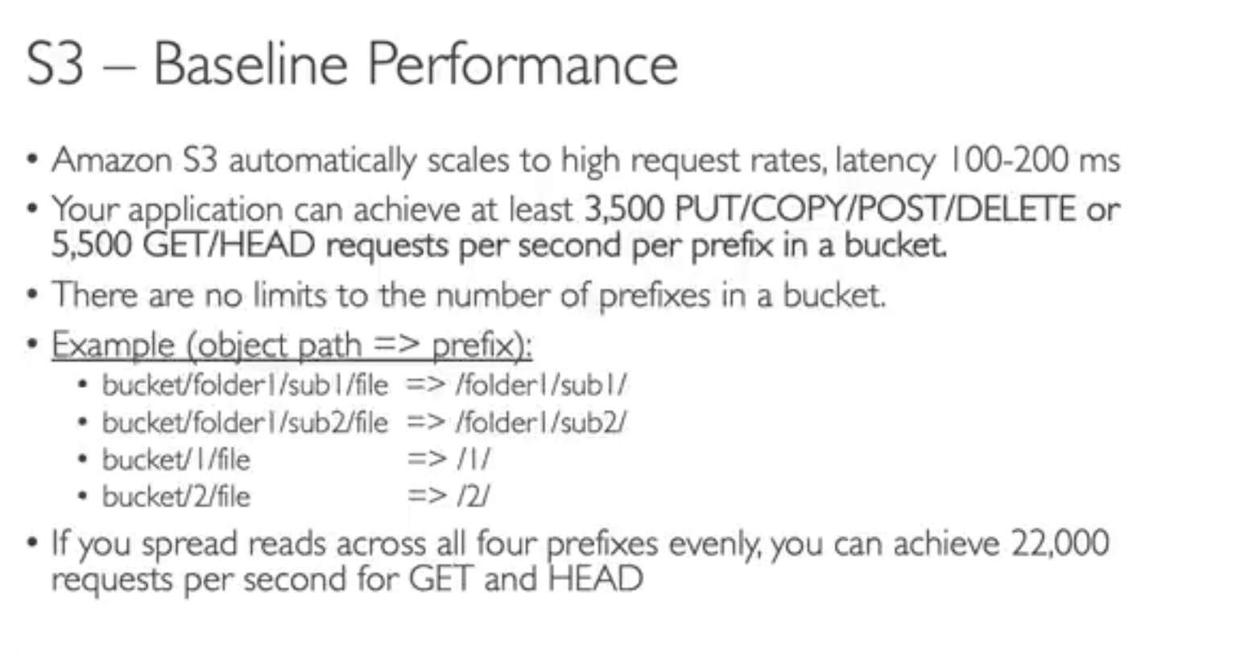

In multipart upload big files are split into smaller files and uploaded and again merged back

Transfer Acceleration helps in caching data on edge location and from edge location it transfers via private aws network

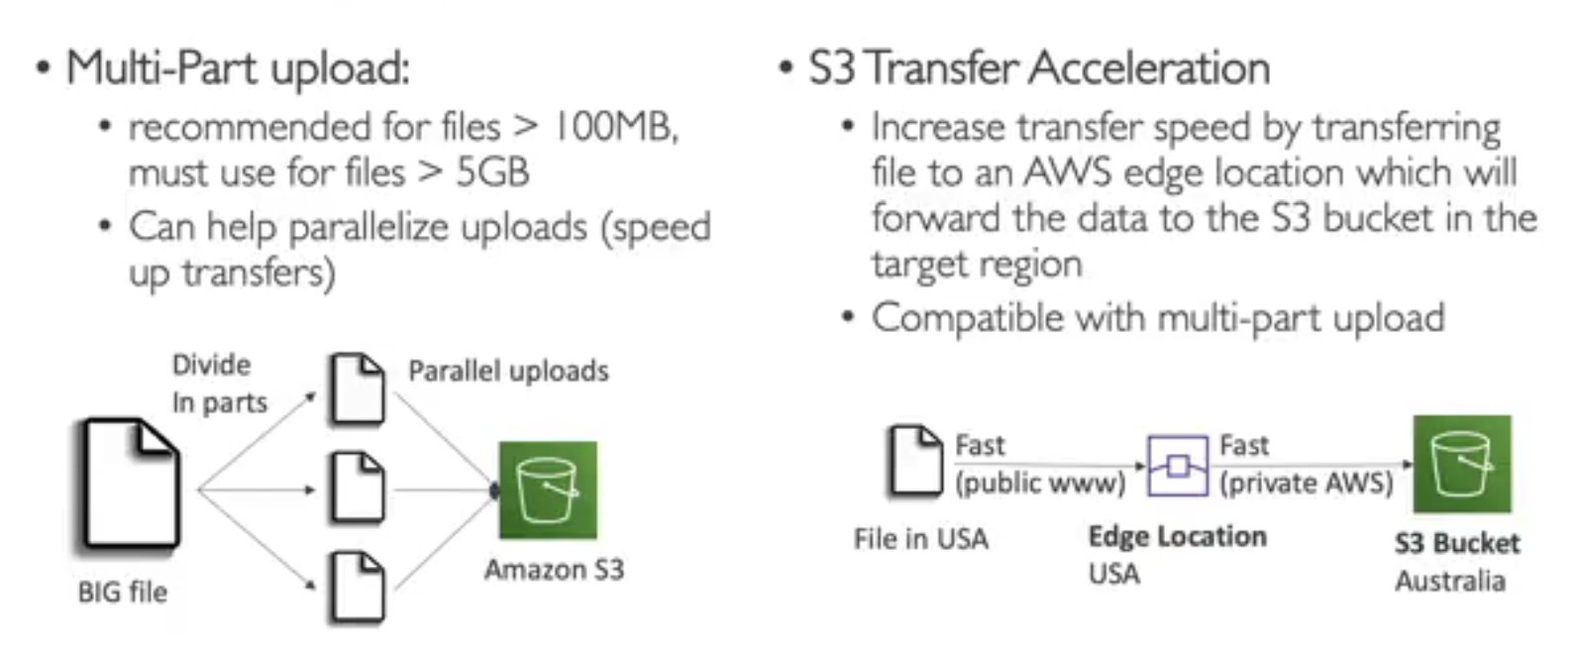

Byte Range:

**S3 Byte Range** is a feature in Amazon S3 that allows you to retrieve specific parts of an object by specifying a byte range in your request. Instead of downloading an entire large file or object, you can use byte range requests to fetch only a certain portion, which can save bandwidth, reduce latency, and improve application performance, especially when working with large files.

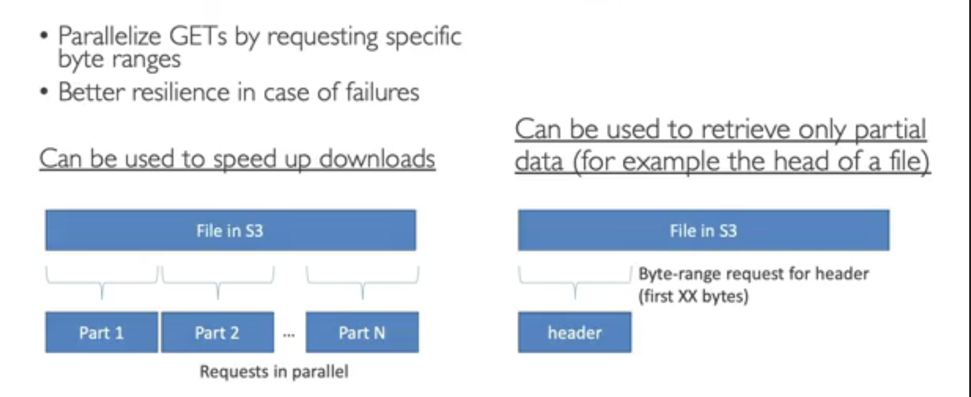

Encryption:

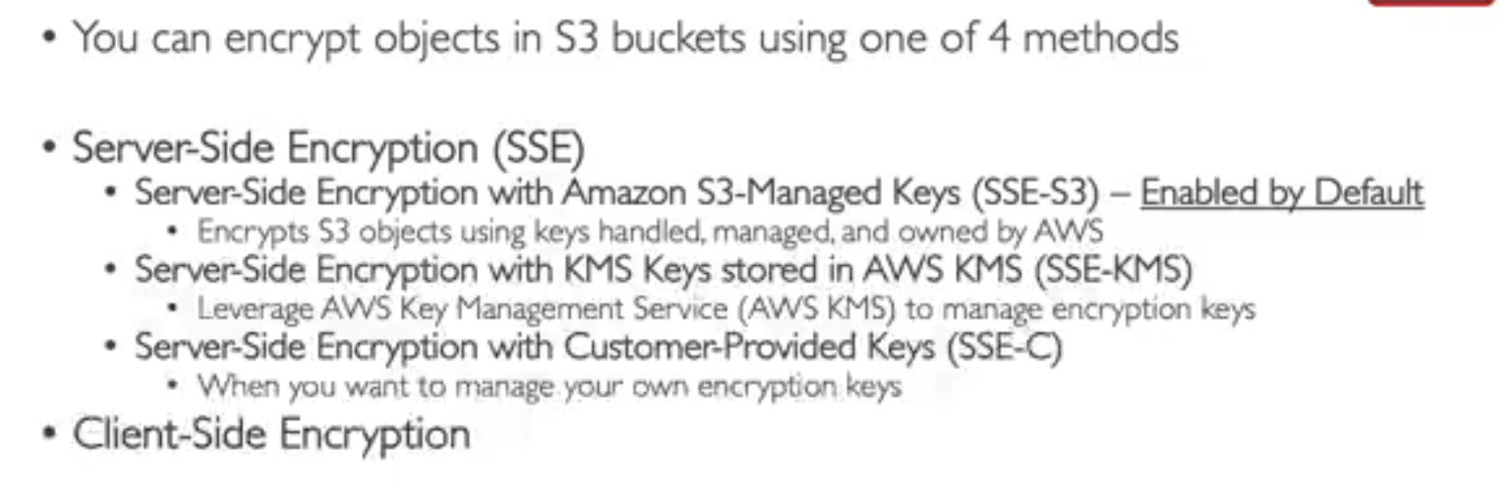

S3 Managed Keys:

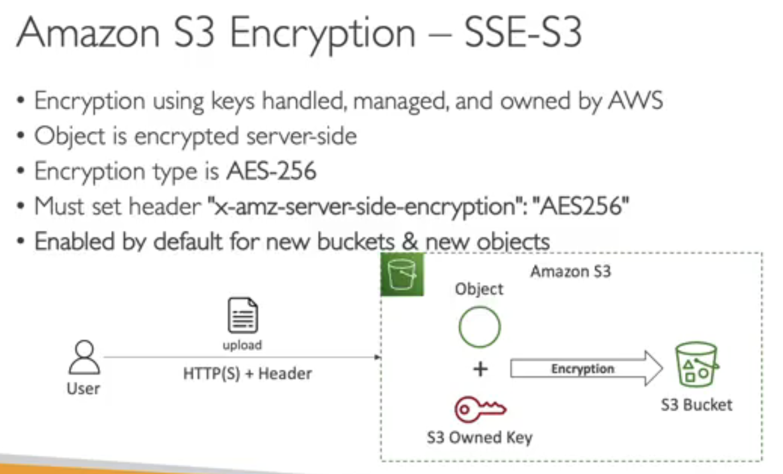

When user uploads with proper header object is created in S3 and it will be paried with s3 owned key and will be encryted

SSE-KMS:

* Here key is managed by key management service (KMS)
* More control & audit can be done in cloud trail
* 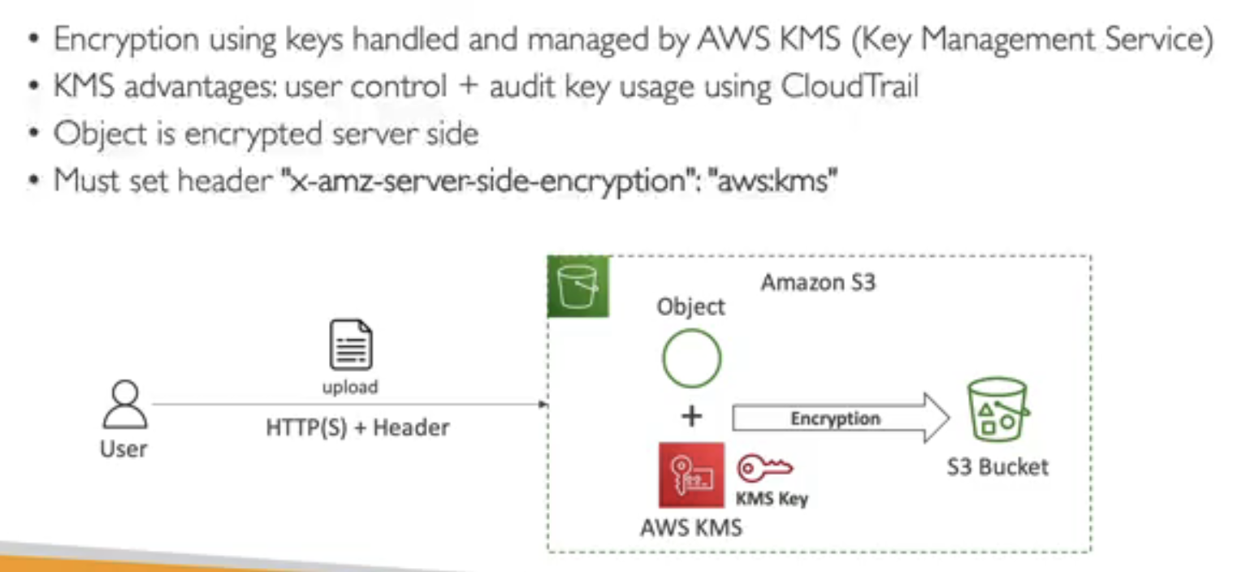
* 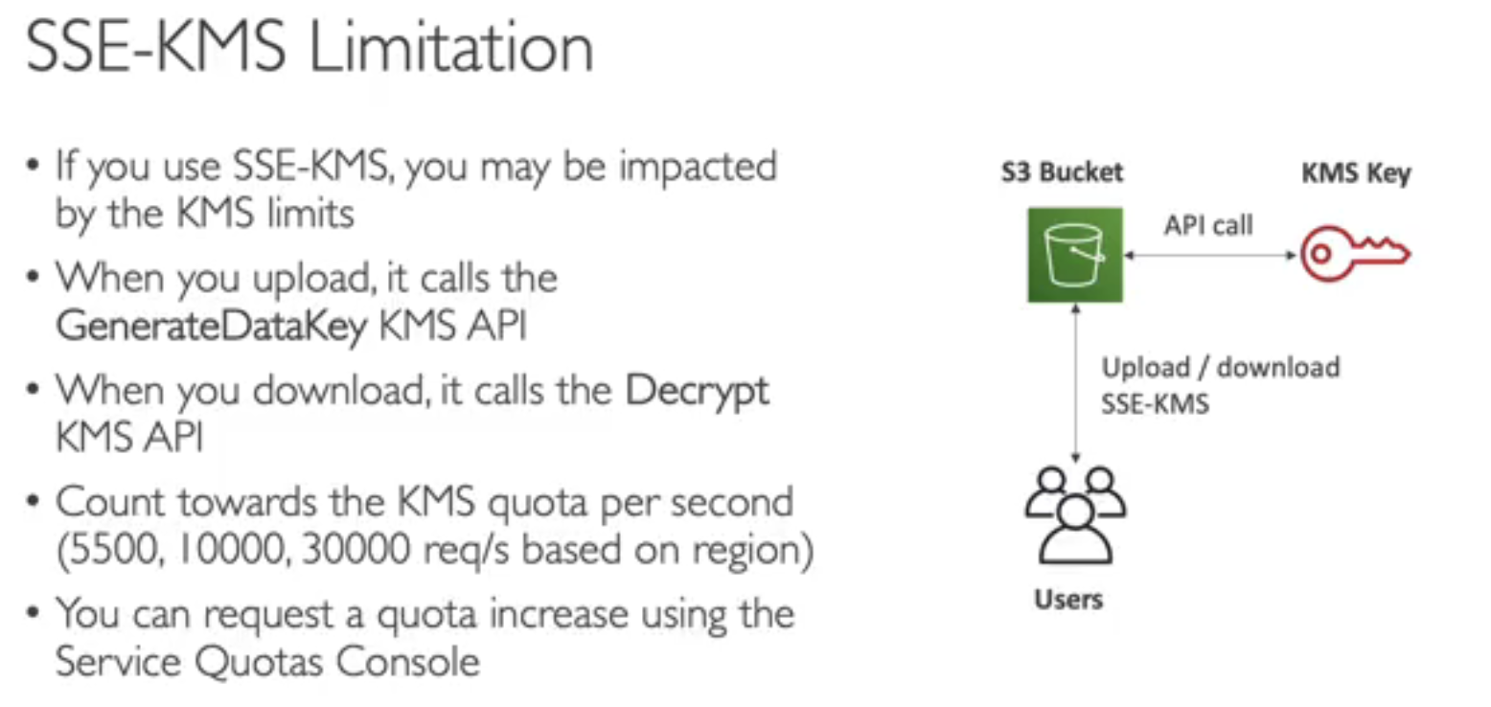

SSE-C

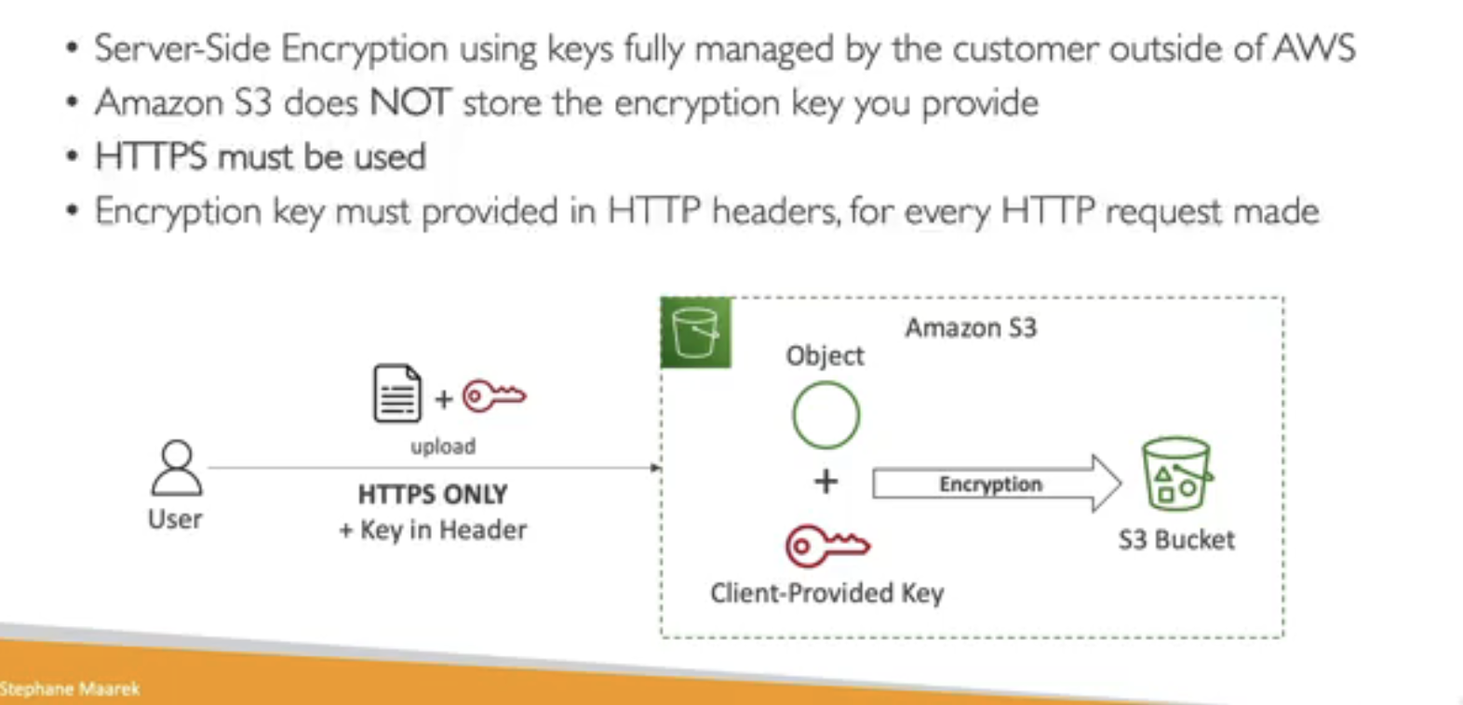

Next, we have the SSE-C type of encryption. So this time, the keys are managed outside of AWS, but it's still servers-side encryption because we send the key to AWS. But Amazon S3 will never store the encryption key you provide. After they're used, they're being discarded. So in that case, because we transmit a key into Amazon S3, we must use HTTPS and we must pass the key as part of HTTP headers for every request being made. The user is going to upload a file, as well as the key, but the user manages the key outside of AWS. And then Amazon S3 will use the client provided key and the objects to perform some encryption and then put the file as encrypted into an S3 bucket. And, of course, to read that file, the user must again provide the key that was used to encrypt that file.

Client Side Encryption:

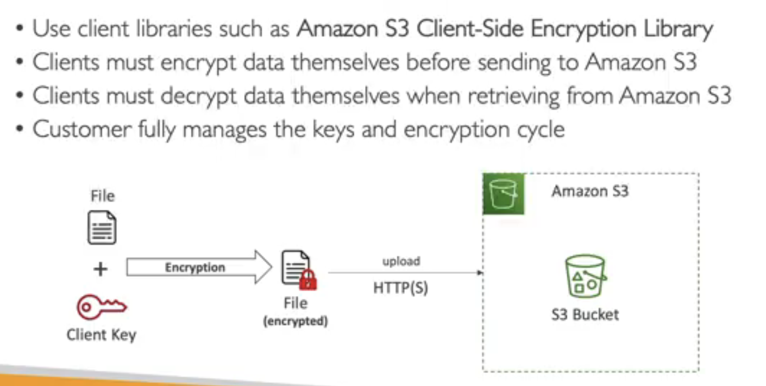

We can secure HTTPS transfer using bucket policy

S3 Access Point:

Instructor: So now let's talk about S3 Access Points. So let's take an example of an S3 bucket that has a lot of data. We have finance data, we have sales data, and we have different users or groups that want to access their data. We could create a very complicated S3 bucket policy and make it grow over time. The more users, the more data you have, the more unmanageable this may become. So what is the solution? Well, we can create what's called S3 access points. So we can, for example, create a finance access point that is going to be connected to the finance data. How is it connected to the finance data? Well, we're going to define an access point policy, and this policy looks just like an S3 bucket policy and is going to grant read/write access to the finance prefix. Then we can define a sales access point. And again, this will be connected to the sales data thanks to an access point policy, a different one attached to this access point, which is going to grant read and write access to the sales prefix. As you can see, I now have two policy, and if I want to have an analytics access points, well, we can create it so that it points to finance and sales, but in read-only access. So we're going to create our own read-only policy on the analytics access point. So you can see here we have pushed the security management from the S3 bucket policy into the access points, and each access point will have its own security. Therefore, with the proper IAM permissions, then our users can access the finance access points and connect only to the finance part of our bucket.

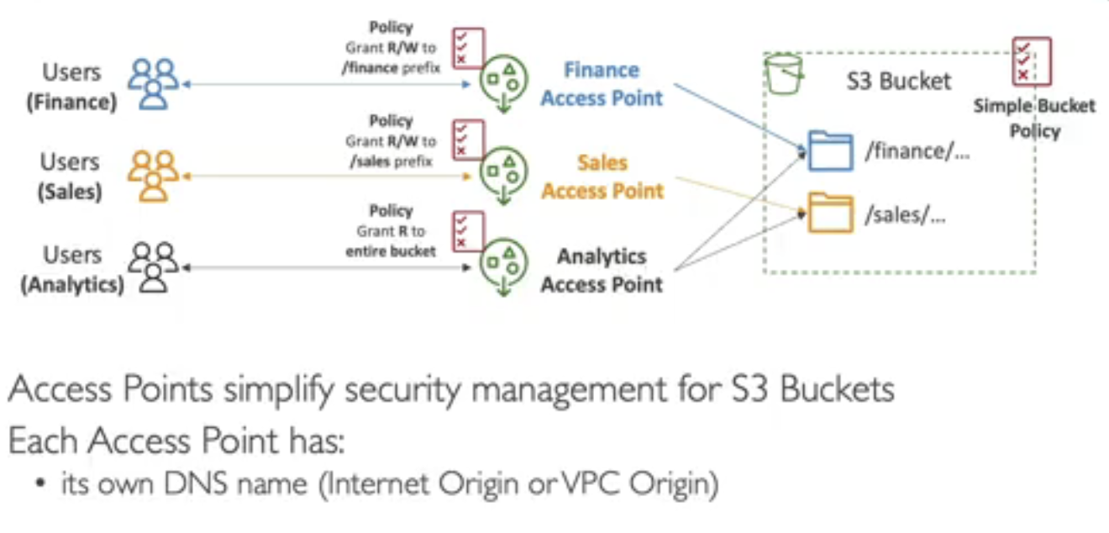

S3 Object Lmabda:

**S3 Object Lambda** is a feature in Amazon S3 that allows you to add custom processing to objects when they are retrieved from S3. You can modify, filter, or transform the content of an object on-the-fly without needing to store modified versions of the object in S3. This is achieved by using an AWS Lambda function that processes the object as it's requested by a user or application.

**Simple Example: Redacting Sensitive Data in S3**

Let's say you have an S3 bucket storing documents with sensitive information, like Social Security numbers or credit card details, and you want to share these documents but without exposing that sensitive information. With S3 Object Lambda, you can set up a Lambda function that redacts (removes or hides) sensitive information before delivering the object to the user.

**Benefits of S3 Object Lambda**

* **On-the-fly Processing**: Modify data in real-time without creating new copies of objects.
* **Data Privacy**: Customize object contents based on user permissions or other conditions.
* **Cost-Effective**: No need to store multiple versions of objects for different formats or redacted content.

EBS (Elastic Block Storage):

* It is a network drive you can attach to a instance while they run
* It allows to persists data even after termination
* 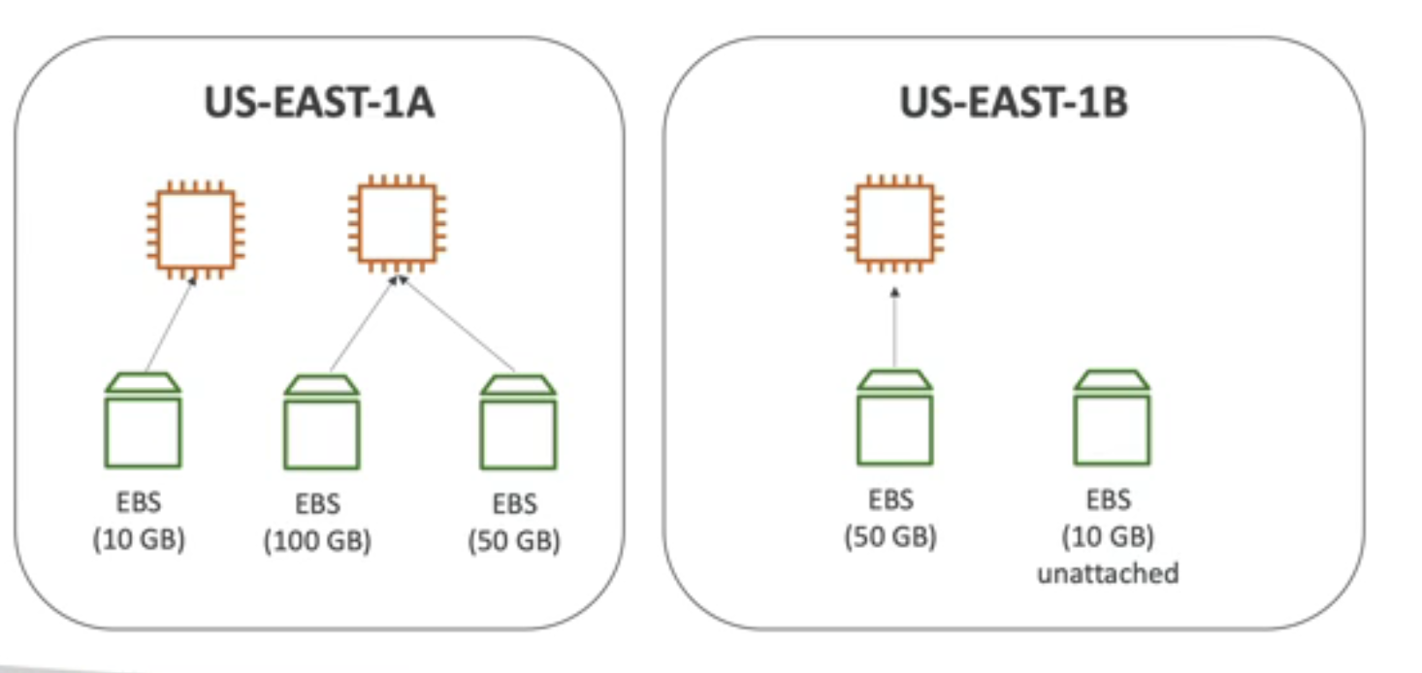
* 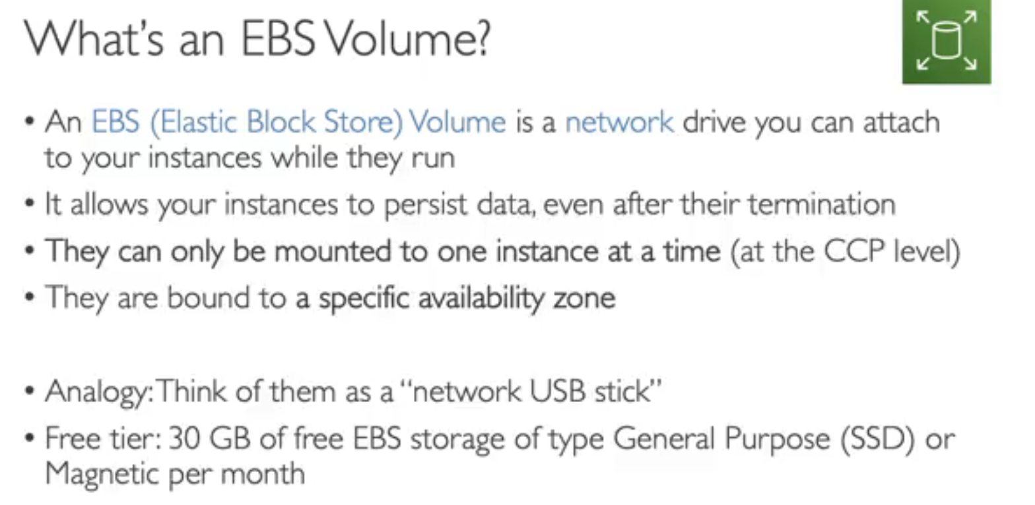
* 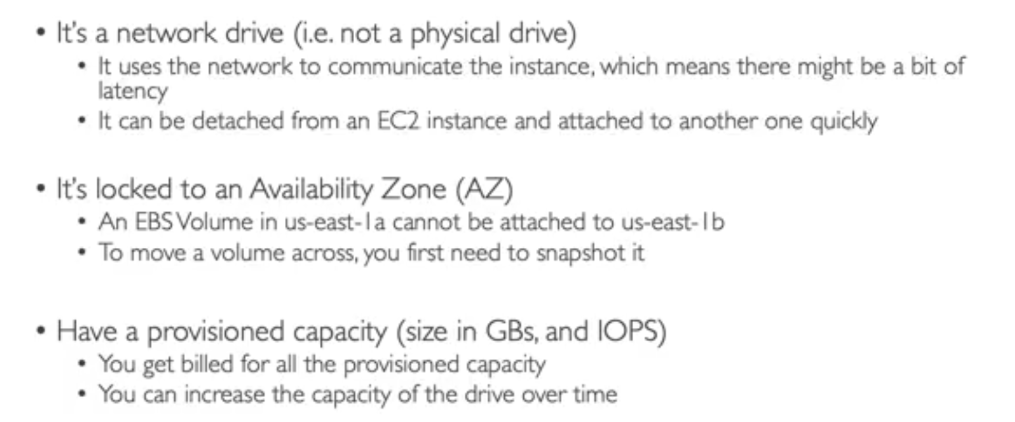
* We can increase block size without detaching, here we can’t decrease and also we can change volume type on the fly

EFS (Elastic File System):

So EFS is a managed NFS, which is a network file system. And because it's a network file system, it can be mounted on many EC2 instances, and these EC2 instances can also be in different availability zones, that's the whole power of EFS.

that it's only compatible with Linux-based AMI and not Windows.

* 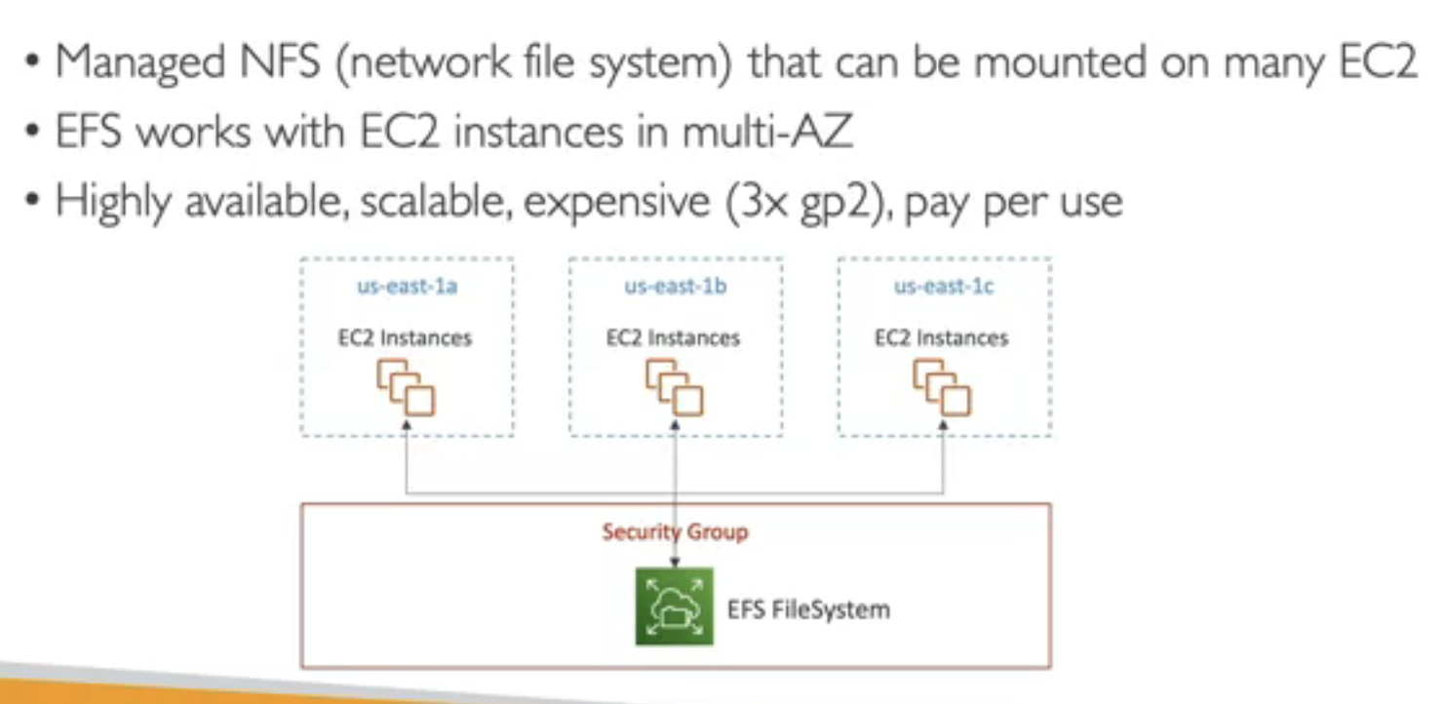

And the cool thing about EFS is that you don't need to plan the capacity in advance. The file system will scale automatically, and it's pay-per-use for each gigabyte of data you use in EFS.

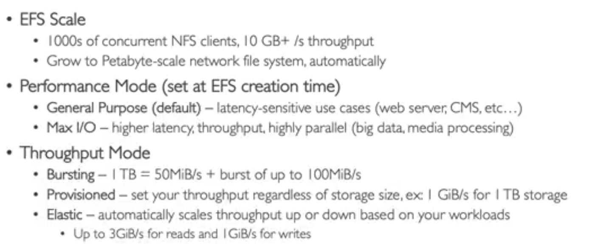

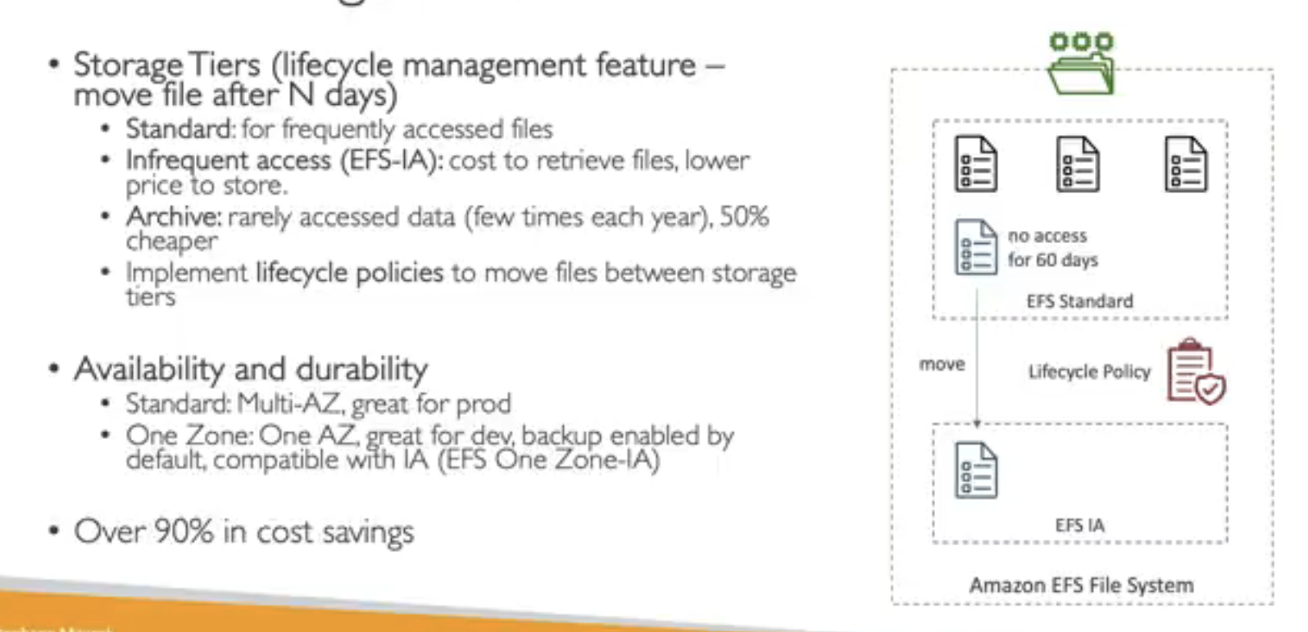

AWS Backup:

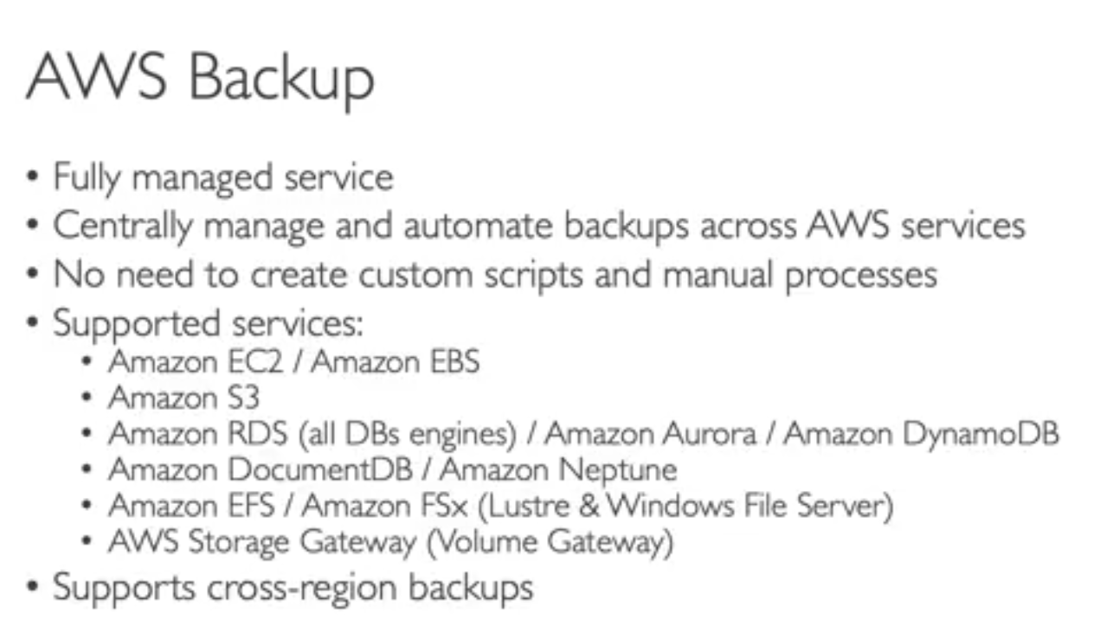

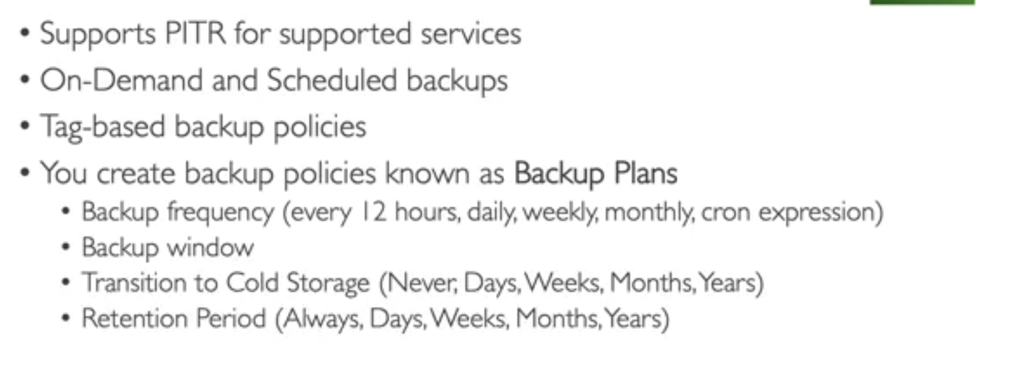

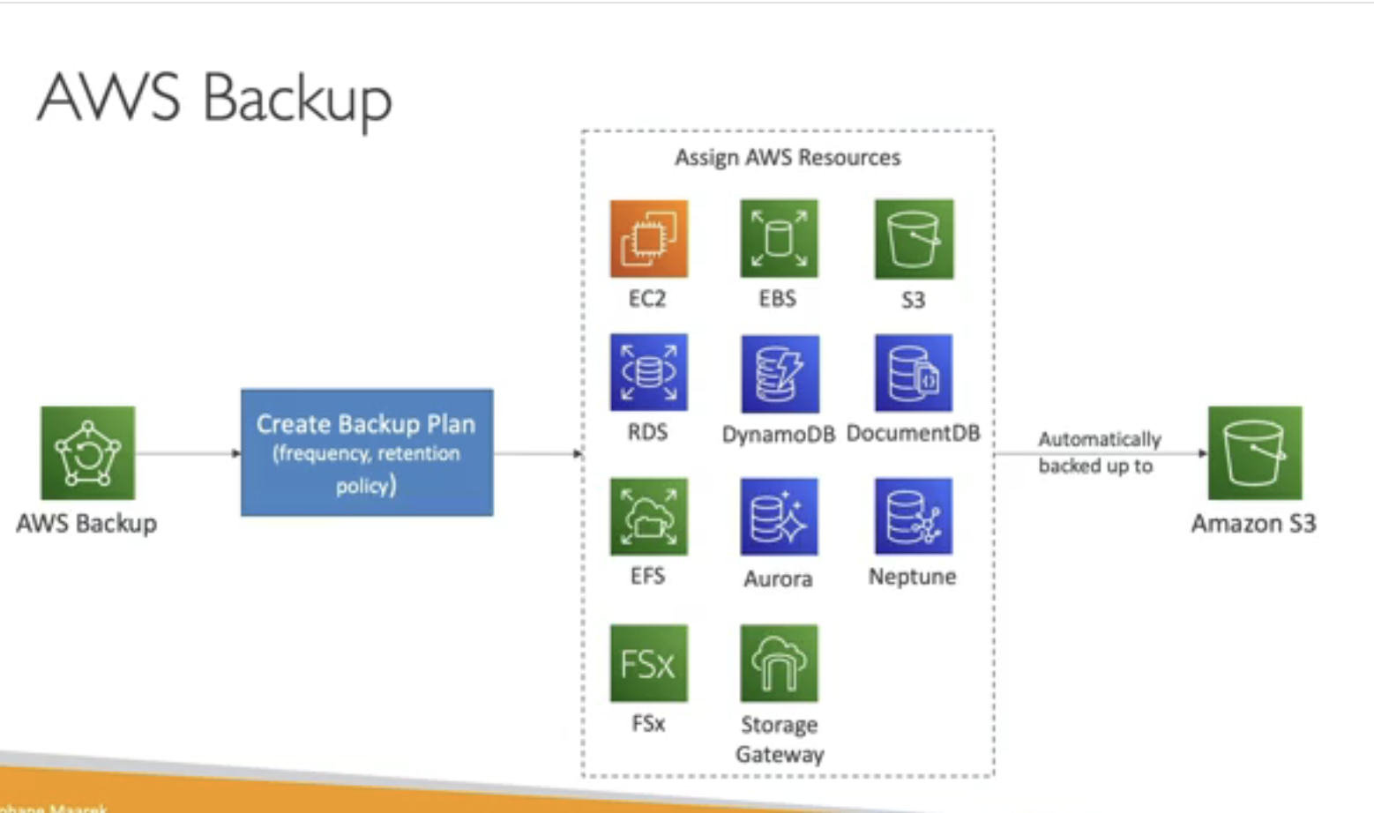

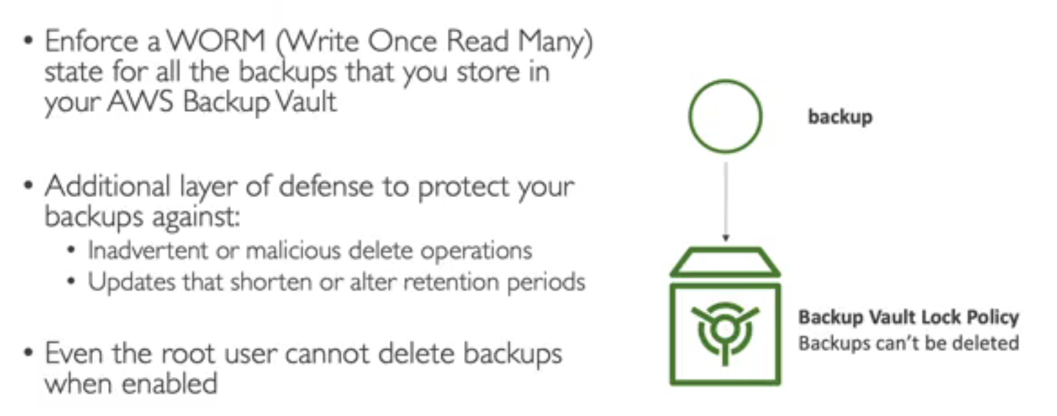

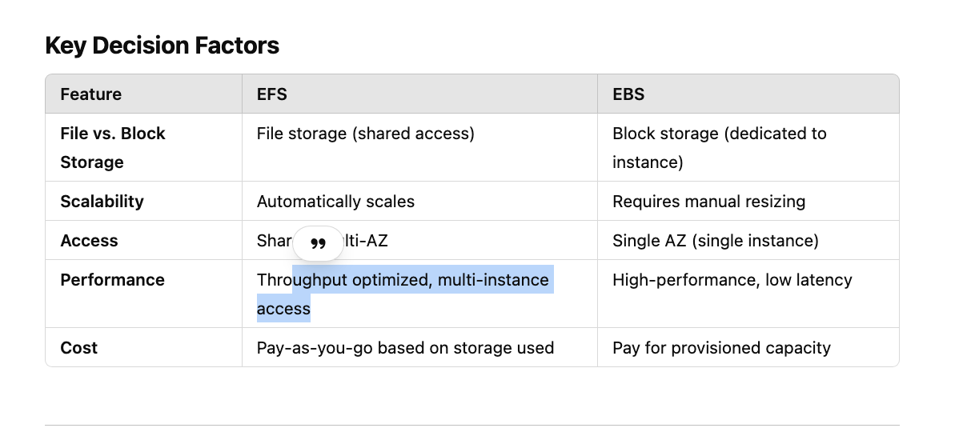

S3 Access Points Hands-On:  
Create Policy:

{

"Version": "2012-10-17",

"Statement": [

{

"Sid": "VisualEditor0",

"Effect": "Allow",

"Action": [

"s3:GetAccessPoint",

"s3:ListAllMyBuckets",

"s3:ListAccessPoints",

"s3:ListMultiRegionAccessPoints",

"s3:ListBucket"

],

"Resource": "*"

}

]

}

And attach policy 2 users

Create bucket and add bucket policy like below:

{

"Version": "2012-10-17",

"Id": "Policy1735133709427",

"Statement": [

{

"Sid": "Stmt1735133707498",

"Effect": "Allow",

"Principal": "*",

"Action": "s3:*",

"Resource": [

"arn:aws:s3:::s3lutaccesss-test",

"arn:aws:s3:::s3lutaccesss-test/*"

],

"Condition": {

"StringEquals": {

"s3:DataAccessPointAccount": "816069129520"

}

}

}

]

}

Next Create access point:

{

"Version": "2012-10-17",

"Statement": [

{

"Sid": "Statement1",

"Effect": "Allow",

"Principal": {

"AWS": "arn:aws:iam::816069129520:user/A-Team-User-1"

},

"Action": [

"s3:GetObject",

"s3:PutObject"

],

"Resource": "arn:aws:s3:ap-south-1:816069129520:accesspoint/user-a1/object/team-a/*"

}

]

}